Meet Satya

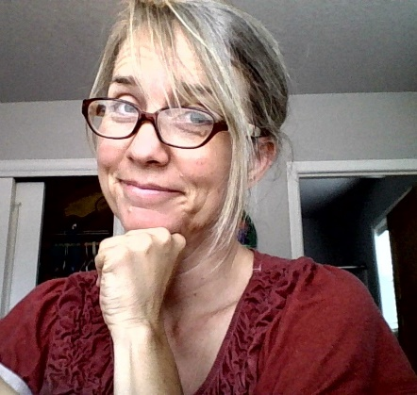
I have always liked to have fun; avoiding boredom was a skill I cultivated in my earliest years. While there are times for real “seriousness” in life, I have learned that integrating curiosity, joy, laughter and gratitude not only helps us think more creatively and remember more, it helps us feel better connected to ourselves and others. I take this zest for life into my work.
After short stints working with CPS and teaching middle school, I found myself drawn to and immersed in the field of family strengthening and child abuse prevention. Since 1998, I have worked as an adoption counselor and mediator, Healthy Families America home visitor, supervisor/manager, QA/TA specialist and trainer for the state of Oregon, and a regional director for Prevent Child Abuse America’s Healthy Families America model.
I have been developing and delivering training to early childhood prevention programs (home visiting, center-based, foster care) since 2001. Here I am able to merge my love of learning, teaching and growing. Making “training” fun, engaging and nurturing is the goal of my work and it is rooted in the conviction that deepening connections with one another reduces stress, builds resilience and motivates us in powerful ways. My workshops are facilitated with “storytelling from the trenches,” research studies, video, discussion and art – creating a whole brain approach to digging deeper into concepts that help us grow and flourish.
My personal experience with burnout and the journey back to restoration informs my work and keeps my focus on finding ways to give our gifts while staying healthy, balanced and motivated. I am passionate about the parallel process and how trauma informed supervision and management practices can support the physical, emotional and spiritual health of staff – so that they can do the same for the families that they serve.
One of the things I love most about this field is how profoundly the work works on you. I enjoy exploring and reflecting upon how the work has shaped me and how I in turn shape it. The continual growth process is the real journey we are all on, and the part I enjoy the most.
I have two grown children and currently reside in Salem Oregon. I have post-graduate degrees in education and family and human services, from Eastern Michigan University and the University of Oregon, respectively.

